THE FOLLOWING PREDICTIONS AND DATA WERE UPLOADED TO TWITTER/ X. NOTE HOW ACCURATE THE PREDICTIONS WERE.

My monthly sunspot "predictions" for 12 yrs up to April 2021 using past data but withholding those last 12 years that gives a correlation of 0.87

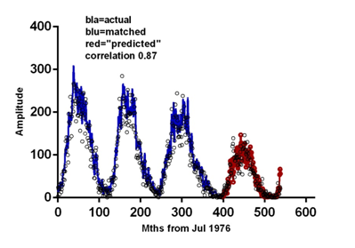NOTE
11:06 AM · May 30, 2022

My annual sunspot "predictions" for 12 yrs up to April 2021 using past data but withholding those 12 years that gives a correlation of 0.98

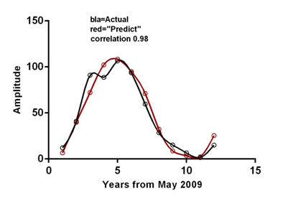
11:07 AM · May 30, 2022

Sunspot maxima have dual peaks. This graph is smoothed with a 12 month running average and the second peak in the current cycle 25 is just starting to show

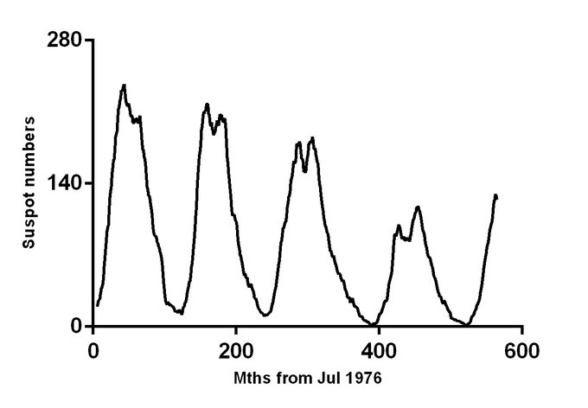
5:57 PM · Jan 23, 2024

Apr 29, 2022
I have discovered the physical processes that account for 87% of the variability in monthly sunspots. The resulting parameters are then matched to historical sunspot numbers for CERTIFIED predictions. HOW CLOSE WILL THE APRIL PREDICTIONS BE? That will be known on 1 May.
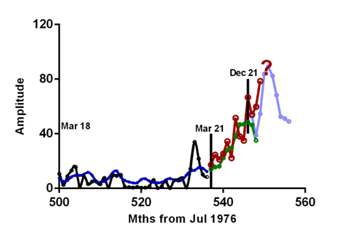
·

May 2, 2022
The April 2022 sunspot data (SIDC) again shows how close our last 14 months of prediction are.
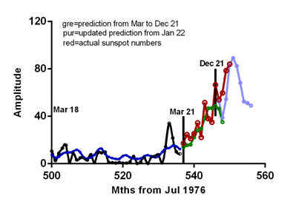

Will Jan23 sunspots be as high as predicted?
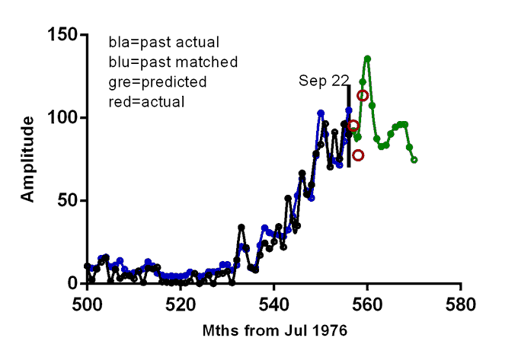
9:01 PM · Jan 16, 2023

My accurate #Jan23 sunspot peak prediction

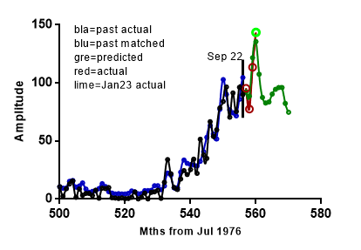
2:16 PM · Feb 2, 2023

Another #successful monthly sunspots prediction for Feb 23 which makes it 24 consecutive months!

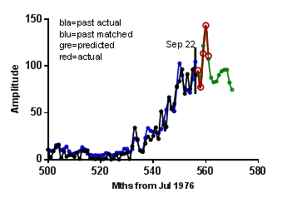
3:24 PM · Mar 2, 2023

My monthly sunspot predictions from Mar21 to Apr23 incl. updated each 6 mths gave a better than expected correlation of 91% (expected 87%)

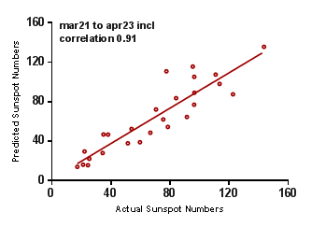
11:36 AM · Jun 7, 2023

My monthly sunspot predictions for the Northern hemisphere of the sun was accurate for Sep-Dec 2023 as shown

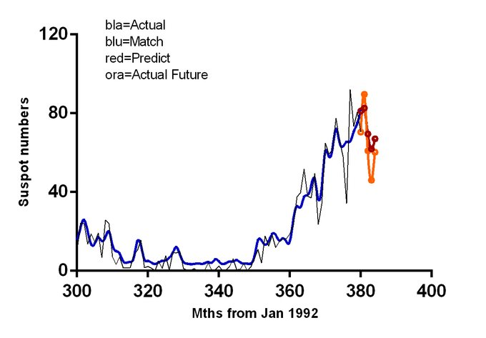
6:00 PM · Jan 23, 2024

The Southern hemisphere monthly sunspots from July 2023 suddenly deviated (orange line) from the predicted trend (red line) for Sep-Dec 2023 because this hemisphere is now only 0.5 times as responsive to the physical processes that drive sunspots

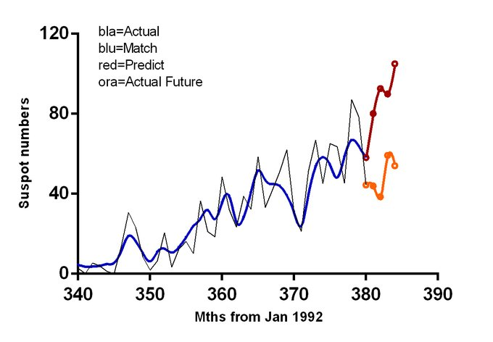
6:04 PM · Jan 23, 2024

My monthly sunspots predictions from Sep-Dec 2023 (red line) are again accurate (compare to orange line) after calculating Northern and Southern hemispheres separately and sunspot numbers are just starting to increase for the second part of the dual maximum

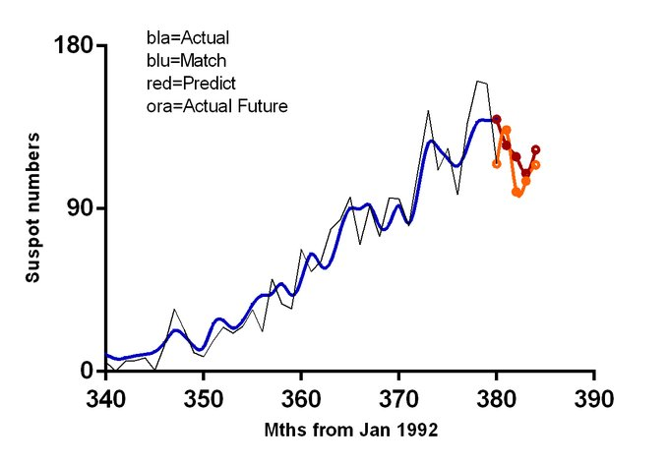
6:11 PM · Jan 23, 2024
At present it is difficult to predict sunspot numbers accurately because there has been a deviation from synchronization between the N and S hemispheres. For 53% sync as Jul-Nov 2023 I predict 110, for 75% sync 124 and 100% sync 140 for Jan 2024.
8:39 PM · Jan 30, 2024

These are my sunspot predictions for April to November 2024 (green) and so far they are extremely accurate (red circles)

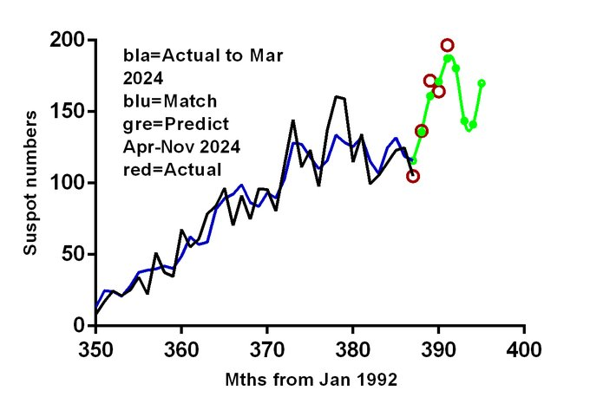
10:52 AM · Aug 9, 2024

My 5 monthly sunspot predictions between March 2021 and July 2024 show a 94% correlation that is even better than the initially anticipated 87% correlation

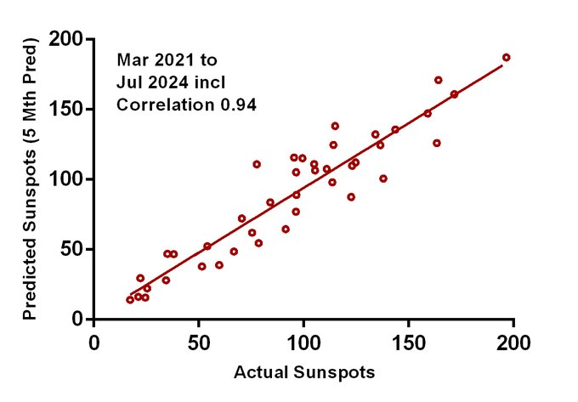
10:54 AM · Aug 9, 2024

